Natural Shape Words – Pictures (2of 3)

**7. Fabiform // Bean shaped**

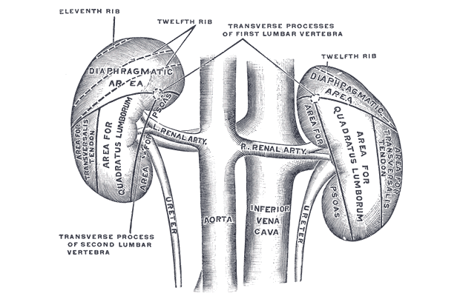

**8. Falcate // Sickle shaped**

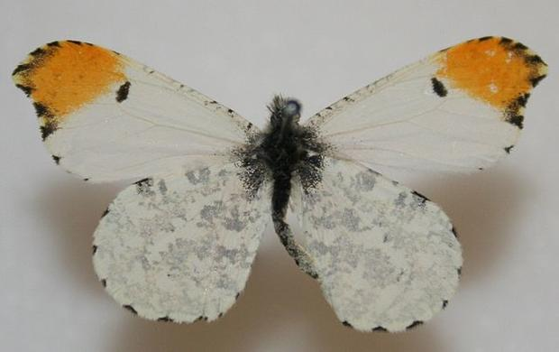

**9. Flabellate // Fan shaped**

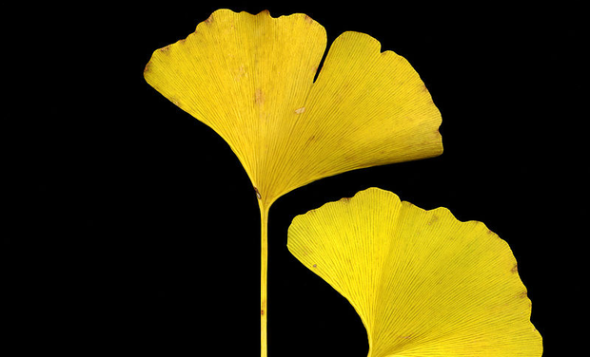

**10. Hastate // Spearhead shaped**

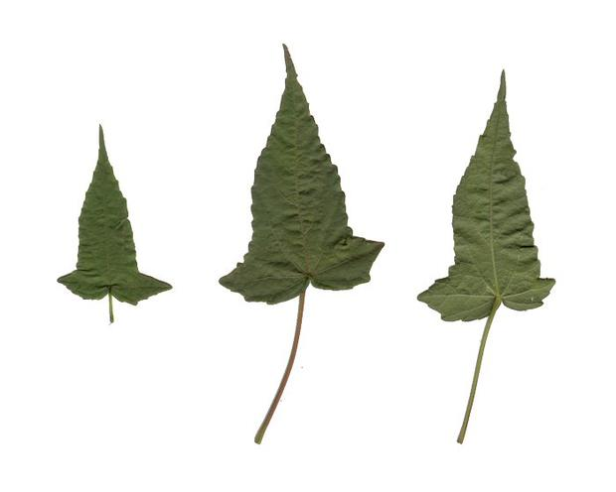

**11. Hippocrepiform // Horseshoe shaped**

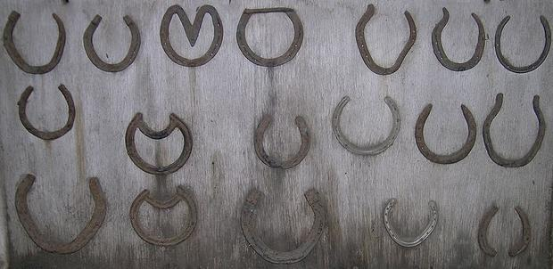

**12. Hordeiform // Barleycorn shaped**

